**Comparative Analysis of a Gene from GenBank Across Species**

**OBJECTIVE: R**etrieving the DNA sequence (e.g., COX1 gene, Haemoglobin gene, or rRNA gene) from different species and compare them to understand evolutionary relationships.

**TOOLS:** NCBI, Clustal omega

**PROCEDURE:**

1. Selection of gene – For this project I have selected gene **COX1 (cytochrome oxidase I).**
2. Retrieving the DNA sequence – Using NCBI to get the FASTA format of the selected the gene of different species like Homo sapiens (human being), Gallus (chicken), Mus musculus(mouse). For my assistance as a readable took only sequence from 100-170
3. Multiple sequence alignment- used Clustal omega for MSA and got the great result

* the alignment, some stretches are full of * → these regions are conserved across all 3 species.
* Red nucleotides (mismatches) indicate **variation**.
* 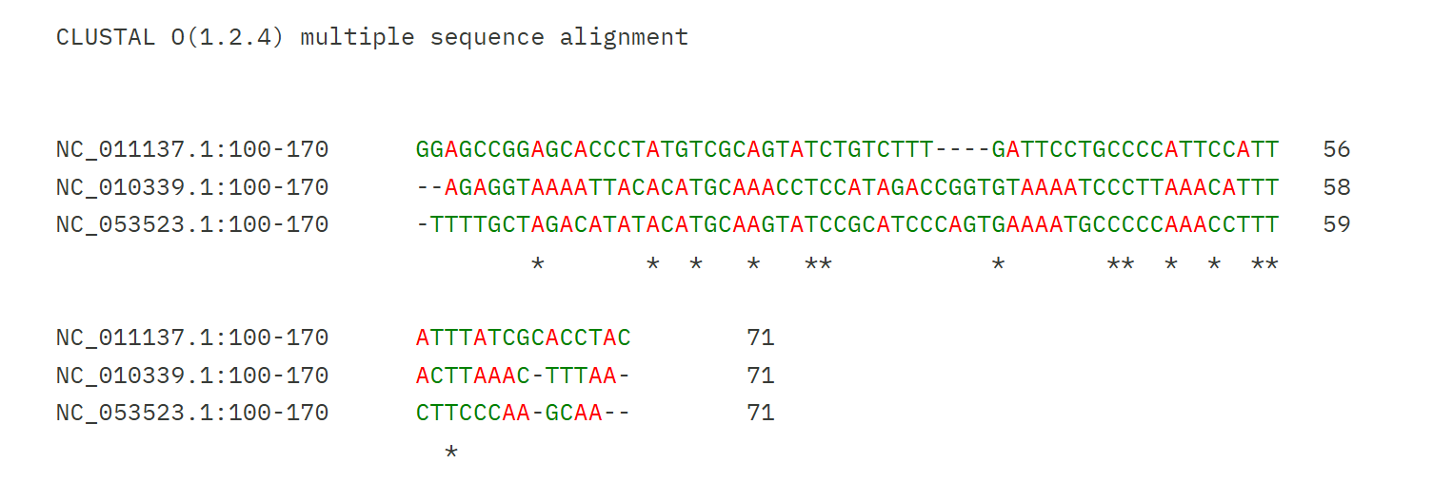Gaps (-) show **insertions/deletions**.

1. DISCUSSION- The alignment revealed that the COX1 gene is highly conserved across the three species studied. Several continuous stretches of * indicated that many nucleotides are identical, suggesting evolutionary conservation of this gene due to its critical role in cellular respiration. At the same time, some variable positions (mismatches and gaps) were observed, which reflect evolutionary divergence among the species. These variations provide useful information for distinguishing species and studying their evolutionary distances. Even without a phylogenetic tree, the alignment itself demonstrates the conserved nature of the COX1 gene and highlights regions that are critical for function.
2. CONCLUSION- This project successfully demonstrated the retrieval of DNA sequences from the NCBI GenBank database and their comparison using multiple sequence alignment through Clustal Omega. The analysis revealed conserved regions in the COX1 gene across human, mouse, and chicken, highlighting its evolutionary importance and functional conservation. This project also shows the usefulness of bioinformatics tools in comparing genes across species.